WSDOT Scientific Reporter
Programmer’s Manual
Version 0.0 - Draft



Table of Contents
1. Introduction
2. Using the Scientific Reporter
2.1 Top-Level Stuff
2.2 Creating Your Own Chapters
2.2.1 Assembling WsChapters - WsParagraphs
2.3 Assembling WsParagraphs - WsReportContent (WsRc*’s)
2.3.1 Shortcuts for Inserting Report Content into Paragraphs
2.3.1.1 Strings and Text
2.3.1.2 Numbers
2.3.1.3 Colors
2.3.1.4 Font Modifiers
2.3.1.5 Page Breaks
2.3.1.6 Line Breaks
2.3.1.7 Tabs
2.4 Styles - The Chain of Responsibility
2.5 PageLayouts - The Chain of Responsibility
2.6 Hyperlinks - Linking Report Content
2.7 Creating the Report - The WsReportBuilder and WsReportSpecification Classes
2.7.1 Creating the WsReportSpecification Class
2.7.2 Creating the WsReportBuilder Class
2.8 Setting Up Your Own Library - The WsUnitLibrary Class
3. The Different Types of Report Content
3.1 Visible WsReportContent Classes
3.1.1 WsRcDateTime
3.1.2 WsRcInt - integer/long values
3.1.3 WsRcReal - united float/double values
3.1.4 WsRcString - std::string’s or char*’s
3.1.5 WsRcSymbol - Greek and math symbols
3.1.6 WsRcTable
3.1.7 WsRcUnsigned - unsigned integers
3.2 Control WsReportContent Classes
3.2.1 WsRcColor
3.2.2 RsRcFlowModifier
3.2.3 WsRcFontModifier -
3.2.4 WsRcHypertarget
4. Features Not Currently Supported by the Scientific Reporter
4.1 Multi-Column pages
4.2 Changing of type face and font size within a WsParagraph
4.3 Page Numbering
4.4 Pictures
5. Gotchas
5.1 No checking to see if report content is assigned to the same paragraph. This will create a problem when more than one paragraph tries to delete the content
5.2 Tabs don’t work for HTML and work only on half inch increments for RTF.
5.3 Bullets don’t work properly in rtf - Bullet just inserts a bullet character before a paragraph.
5.4 Style chain of responsibility does not work for page headers & footers
6. HTML Vs RTF: A Feature Comparison
6.1 HTML
6.1.1 Pros
6.1.2 Cons
6.2 RTF
6.2.1 Pros
6.2.2 Cons

Introduction
The Scientific Reporter is a structured, object-oriented software framework for creating scientific and engineering reports. The Reporter eases report creation by automating tasks such as unit conversion, table creation, and pagination. The Reporter also allows the user to create reports in a file format independent manner. Two output file formats are currently supported: RTF and HTML. The Reporter does not provide a view for either type of file.

The Scientific Reporter was coded in C++ using Object-Oriented design methods. Many of the object designs used in the creation of this tool were adapted (or plain ‘ol copied) from the Design Patterns book by Gamma et al. If you have not read this book, it is well worth doing so, not just for understanding this program, but for your own professional development. The following patterns were used in this project: Framework (the whole enchilada), Chain of Responsibility (styles), Composite (tables), Visitor (the report/chapter/paragraph/report content visitors), Prototype (set table by column functions, and the WsRcReal streaming functions), and Singleton (FontStyleLibrary, UnitSystem).

The Reporter provides its own simple, structured view of looking at a report. This view is outlined in Figure 1Below.
A text description of the layout of a Reporter report is as follows (using the C++ class names):
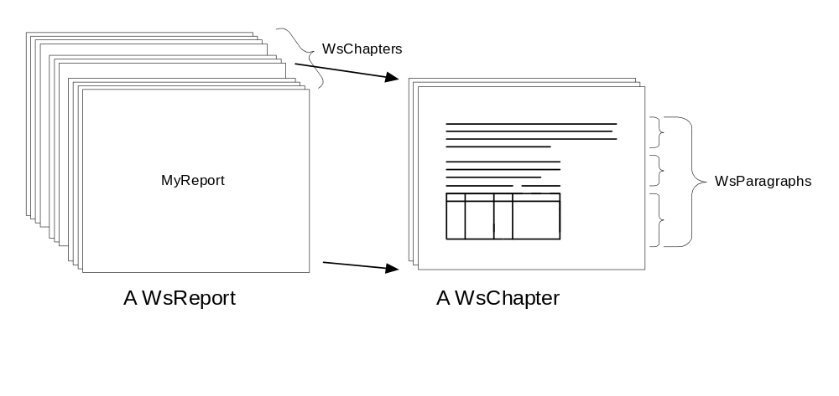Figure 1
- A WsReport is composed of one or more WsChapter’s
- A WsChapter is composed of one or more WsParagraph’s
- A WsParagraph is composed of one or more pieces of WsReportContent and is always terminated by a carriage return.
- The Reporter currently supports the following different types of WsReportContent
- WsRcColor - a stream modifier which changes the color of all report content to follow in the current paragraph
- WsRcDateTime - the current date and time
- RsRcFlowModifier - pagination modifiers such as page breaks, line breaks and tabs.
- WsRcFontModifier - typographical modifier for turning to following on or off: bold, italics, underline, subscript and superscript.
- WsRcHypertarget - an invisible target for a hyperlink.
- WsRcInt - integer/long values
- WsRcReal - united float/double values
- WsRcString - std::string’s or char*’s
- WsRcSymbol - Greek and math symbols
- WsRcTable - multicolumn tables
- WsRcUnsigned - unsigned integers

Using the Scientific Reporter
Probably the best way to learn to use the Scientific Reporter is to first browse through this document and then take a look at the sample application in the ReporterTest directory.

Top-Level Stuff
The sample application in the ReporterTest directory provides a typical top-level implementation of a report. The basic steps for adding Reporter capabilities to a new application follow. Note that you do not necessarily have to follow this sequence exactly:
- Load unit definitions and categories into a WsUnitLibrary - derived class.
- Determine the font styles that you will use in your report and add them to the FontStyleLibrary-derived class so that they may be referenced by name when creating chapters, paragraphs, and report content.
- Derive specialized WsChapter’s for each of the logical sections that you would like to break your report into. Insert WsParagraph’s into your chapters and fill each paragraph with WsReportContent. Insert the WsChapters into the WsReport.
- After the report is built, use a ReportVisitor-derived class to create an ostream containing the final format of the report (e.g., html, rtf).
- Display the report using your favorite viewer.
Again, the best way to learn the basics about using the Reporter is to examine the source code in the ReporterTest directory.

Setting Up Your Own Unit Library - The WsUnitLibrary Class
The WsUnitLibrary class is a container for the physical units that may be used by the reporting system at run-time. A complete list of physical unit types that are available in the library is given in the PhysicalUnitType enum contained in the UnitLibrary.h header file. If you decide to add more physical unit types to the library, they should be added to the WsUnitLibrary base class.

When the WsUnitLibary is constructed, the output units for the library are those described in the DefaultOutputUnits parameter to the constructor. You will likely want to add more categories of output units to your application other than the default. This can be done by creating you own derived WsUnitLibary class and providing your own member function to load in unit categories that you would like to use in your application. Refer to the UnitSystem documentation for more information on how to use the UnitLibrary class.

Setting up a FontStyleLibrary
The Reporter system does not allow you to change the font and font size of report content directly at run-time. Instead, you are provided with a method of defining named “font styles” prior to building your report. Each font style defines a set of attributes such as font type, font size, color, boldness, italics, etc. that may be used to create visually attractive reports.

The idea behind named styles is much the same as that for using styles in your favorite word processor. You simply set up the typography options for a given name (e.g., “Header1”, “FigureHeading”, “ChapterTitle”, etc..) and then reference that name when you want to apply the style to chapters and paragraphs. The use of named styles allows you to easily create a report that has consistent style throughout its contents. If you decide not to utilize the named style feature in your reports, the style library creates a default style, named “Default”, which will be used internally for all text in the reports.

The FontStyleLibrary is a singleton object that must be initialized before any reports are built if you plan to use named styles. Initialization takes place by manually adding named styles to the library. Named styles are added to the library by making calls to the AddNamedStyle(const StyleName& rmyName, const WsRiStyle& rmyStyle); member function for each StyleName. At this level, a named style is simply a mapping between a StyleName and a WsRiStyle object. The WsRiStyle class represents all of the different typography options that are available the Reporter system. Refer to the WsRiStyle.h header file for more details.

Creating Your Own Chapters
The majority of the work that you will be doing in coding up your reports will be in the creation and addition of report content to WsChapter’s. You should create a chapter for each logical topic that you add to your report. (e.g., “Unfactored Moments and Forces Chapter”). This will allow you to break up and reorder the sequence of information in your report easily.

WsChapters must always be constructed on the heap. This is because they will be deleted in the WsReport’s destructor. The WsChapter constructor requires the specification of a chapter name. This name should be a short (50 chars or less), meaningful description of the chapter. Some WsOutputVisitors may use this name as an entry in a table of contents or in the chapter page header.

After the WsChapter is created, it’s pointer must be inserted into the report using the WsReport’s << operator in order for the chapter to become a part of the report. Although not necessary, a good time to insert the WsChapter into the WsReport is immediately after it is constructed. This will make it easy to check the code to see that it is added to the report properly. After the WsChapter has been inserted into a WsReport, the WsReport “owns” its memory. This means that you must not delete the WsChapter explicitly. Also, you must not insert the same WsChapter into a WsReport twice or into two different WsReports.

Assembling WsChapters - WsParagraphs
The next step after you have constructed your WsChapter and inserted it into the WsReport, is to insert concrete WsParagraph objects into it and then add WsReportContent to the WsParagraphs. This is the actual “dirty work” of creating the report.

As far as the report is considered, a WsParagraph is a contiguous grouping (container) of report content that may be assigned a specific named style. All WsParagraphs are automatically followed by a line break.

There are two different constructors for WsParagraph’s depending on whether you want to explicitly specify style information for it or not. Each version is discussed below. Refer to Section 2.6 for a discussion of the style chain of responsibility.

- WsParagraph() - Construct a paragraph using the style of the parent WsChapter or WsReport.
- WsParagraph( const StyleName& myStyle ) - Construct a WsParagraph and assign it a style name which exists in the WsFontStyleLibrary.

WsParagraphs are inserted into WsChapters by use of the WsChapter << operators. Inspection of the Chapter.h file reveals that there are two << operators: The first takes a WsParagraph object and the second takes a pointer to a WsParagraph object. The first member function makes a copy of the WsParagraph and stores it. The second member function simply copies the pointer into the WsChapter. The WsChapter will delete this pointer when it is destructed. Hence, any WsParagraphs inserted using the second member function must be created on the heap. Note that making a copy of a paragraph can be computationally expensive: Always try to use the second member function for large WsParagraphs, especially those which contain WsRcTables.

Assembling WsParagraphs - WsReportContent (WsRc*’s)
After a WsParagraph is constructed, it is filled up with information by inserting WsReportContent-derived objects into it.

The information for a report is typically gathered by making calls to member functions of “business objects” in your problem domain and then using that information to create report content which describes the information. This means that you will typically encounter a lot of coupling between the Reporter and your application in your report building functions. This is to be expected, because face it reporting is a dirty job. However, you should attempt to keep things as modular as possible by restricting the coupled code to a localized area.

WsReportContent is an abstract class that provides the “meat” of your report. It consists of all of the text, numbers, symbols, tables and controlling information that fills the pages of a report.

The methods for inserting WsReportContent into a WsParagraph are identical in nature to the methods for Inserting WsParagraphs into a WsChapter. However, there are some additional methods making it easier to insert commonly-used WsReportContent into paragraphs. These additional methods are discussed in Section 3 and in the Paragraph.h header file.

There are two primary methods for inserting WsReportContent into a WsParagraph: The first takes a WsReportContent-derived object and the second takes a pointer to a WsReportContent-derived object. The first member function makes a copy of the WsReportContent and stores it. The second member function simply copies the pointer into the WsParagraph. The WsParagraph will delete this pointer when it is destroyed. Hence, any WsReportContent inserted using the second member function should be created on the heap. Note that making a copy of report content can be computationally expensive: Always try to use the second member function for WsRcTables unless a copy operation is appropriate for the task at hand

Shortcuts for Inserting Report Content into Paragraphs

Strings and Text
std::strings, string literals and char*’s can be inserted directly into a WsParagraph. They are automatically copied and converted to WsRcStrings and given default style information (default means that style is inherited from the style chain of responsibility).

Numbers
floats, doubles, ints, unsigns, longs, chars, and literal values can be inserted into a WsParagraph. They are automatically converted into their corresponding WsRc** objects and given default style traits.

Colors
The default color of the output stream may be changed by inserting the color() macro into a WsRcParagraph. Acceptable colors that may be passed into the macro are given in the FontColor enum in RiStyle.h.

Font Modifiers
Attributes of the current font of the output stream can be changed by the bold(), underline(), italic(), subscript(), and superscript() macros. Each of these macros accepts a StateType parameter (defined in RcFontModifier.h) of OFF or ON.

Page Breaks
Page breaks may be inserted into the output stream through use of the np macro. Note that page breaks may not be supported by some target file formats (HTML, for instance).

Line Breaks
Page breaks may be inserted into the output stream through use of the nl macro.

Tabs
Tabs may be inserted into the output stream through use of the tab macro. Note that tabs behave differently in HTML than in RTF.

Styles - The Chain of Responsibility
StyleNames are used to apply stylistic information (e.g., font face, font size, color, font attributes, etc.) to WsParagraphs, WsRcTables, and their corresponding WsReportContent.

Inspection of the WsReportItem class reveals a pointer to a StyleName object and a pointer to a style parent. All content-related classes in the Reporter (e.g., WsReport, WsChapter, WsParagraph, WsReportContent,…) are derived from WsReportItem and hence may be assigned style names and queried for style information. Note that although it is allowable to explicitly set the style of an individual piece of report content, the style is probably ignored by WsOuputRcVisitors and will not show up in a report.

Early on in the design of this framework, it was decided that it does not make sense to have to apply a style object to each and every report item in a report. However, it does make sense for all report items to support a query about their style characteristics. It also is desirable for report items to “inherit” their style from items higher up in the report chain (parents). For example, if a text item does not have a style, it should inherit that style from the paragraph that it is embedded in. Furthermore if the paragraph does not have a style, it should inherit from its chapter and so forth all the way up the default style for the report. This behavior is known in the patterns community as a “Chain of Responsibility”. For the Reporter, the Chain of Responsibility for style information is shown in Figure 2. Note that page headers and footers contained in a WsPageLayout must have explicit styles associated with them.
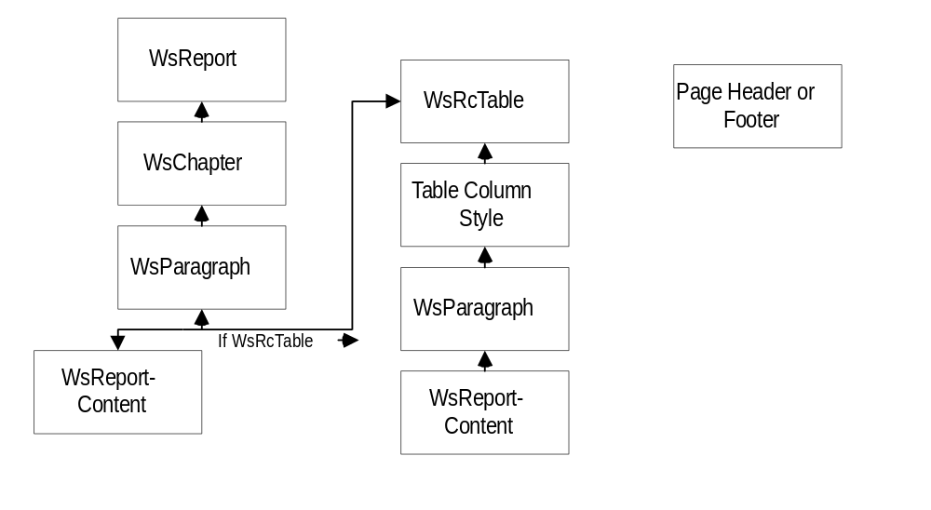
Figure 2
Style Chain of Responsibility

PageLayouts - The Chain of Responsibility
Page Layout information, such as page size, margins, and page headers and footers is contained in the WsPageLayout class. WsPageLayout has a chain of responsibility similar to that of WsRiStyle. However, the page layout chain of responsibility is only between the WsChapter and WsReport classes.

Hyperlinks - Linking Report Content
Hyperlinks are supported by the Reporter by creating WsRcHyperTarget objects and then by setting a WsReportContent-derived object to point to the target. WsRcHyperTargets are invisible report content objects that may be inserted anywhere within any paragraph (including paragraphs in tables). WsRcHyperTargets are constructed with a target name which identifies them. To point a piece of report content at a WsRcHyperTarget, call the WsReportContent::SetHyperLink() member function with the desired target name. Note that no validity or duplicate checking is performed on the links.

The Different Types of Report Content
All Reporter classes that are derived from WsReportContent are named in the form of WsRc*. These classes represent or modify the information that is seen by the user. Hence there are two main types of WsReportContent: Visible WsReportContent and Control WsReportContent. All types of WsReportContent may be streamed (<<’d) into WsParagraphs. The following sections describe the basics for each derived WsReportContent currently available in the Reporter.

Visible WsReportContent Classes
The visible WsReportContent Classes represent all of the text and pictures in the report. The way in which these objects are presented to the user may be modified by the StyleName that is attached to the content (via the chain of responsibility) and by the different Control WsReportContent classes. The following is a complete list of all current Visible WsReportContent Classes. Refer to the Cocoon-generated documentation or the source for a more complete description of the capabilities of each of these classes

WsRcDateTime
This class is used to print out the current date and time. The time that is printed is the time of the construction of the WsRcDateTime object. The EnablePrintDate() and EnablePrintTime() member functions control whether the time is printed, the date is printed, or both are printed. Both date and time are printed by default.

WsRcInt - integer/long values
This class is used to print signed integral data to the report. The width of the output field may be controlled by the SetWidth() member function. The purpose of the Width parameter is to enable the printing of zero-padded integral values such as 007.

WsRcReal - united float/double values
This class is used to print floating point values to the report. All WsRcReal objects (SCALAR is a PhysicalUnitType) are associated with a PhysicalUnitType stored in the unit library.

The SetFormat() member function supports the following modes: RLFIXED, RLSCIENTIFIC, and RLAUTOMATIC. RLFIXED outputs numbers in fixed decimal format, RLSCIENTIFIC outputs numbers in scientific format, and RLAUTOMATIC outputs numbers using the automatic mode associated with the C++ iostreams classes.

The number of digits following the decimal point may be specified using the SetPrecision member function. WsRcReal objects may be given a fixed output width. If the value is too large to fit in the allotted width, the output mode will automatically be set to scientific format.

Three functions that utilize prototyping are provided to facilitate streaming WsRcReal objects into a WsParagraph. All three of the functions create a WsRcReal* from the prototype so that it may be streamed directly into a WsParagraph:
- Sv() - Send string representing value only (e.g., “9.81”).
- Su() - Send unit string associated with WsRcReal only (e.g., “m/s”)
- Svu()- Send value and unit string (e.g., “9.81 m/s”)

WsRcString - std::string’s or char*’s
The WsRcString class is used for sending std::strings and char*’s to the report.

WsRcSymbol - Greek and math symbols
The WsRcSymbol class may be used to send some predefined symbols to the output steam. A complete list of the symbols can be obtained by running the Reporter\Test application.

WsRcTable
This class is used for sending multicolumn tables to the report. The Reporter represents tables as a zero-based, two-dimensional array of WsParagraphs. Hence, anything that you can insert into a WsParagraph, you can insert into a table. However, the behavior for inserting tables into table cells is undefined.
The style chain of responsibility for tables is slightly more complicated than that for other types of WsReportContent and is shown in Section 2.6. The reason for making the style chain more complicated is to allow for the “shotgun” setting of all members in a table column. Functions to set the style of the top row (header row) of a table are also provided.

Member functions are provided to adjust the widths of table borders. Note that the bottom of the first row (header row) is treated separate from the other interior horizontal borders.

The WsRcTable class provides member functions for quickly inserting STL vectors of doubles, longs and std:strings. These column-oriented functions all use a prototype WsReportContent-related object to provide the settings for any report content inserted into the column. Note that calls to the Set*Column() member functions simply append information to the column in question. This allows you to make repeated calls to these functions while you are building your table.

One thing to be careful about with tables is that they can get very big - fast. Avoid writing code that will cause tables to be copied. Large tables should always be allocated on the heap and inserted into WsParagraphs using a pointer.

WsRcUnsigned - unsigned integers
This class is used to print unsigned integral data to the report. The width of the output field may be controlled by the SetWidth() member function. The purpose of the Width parameter is to enable the printing of zero-padded integral values such as 007.

Control WsReportContent Classes

WsRcColor
This class is a stream modifier which changes the color of all report content to follow in the current paragraph. The simplest way to insert color information into a WsParagraph is to use the color() macro.

RsRcFlowModifier
This class is used to put in-line flow and typographical information into the report stream. The flow control modifiers that are supported are line breaks, page breaks and tabs. These modifiers are most easily inserted into the report stream using the nl, np and tab macros, respectively.

WsRcFontModifier -
This class represents typographical modifiers for turning to following font characteristics on or off: bold, italics, underline, subscript and superscript. These modifiers are most easily inserted into a paragraph by using the bold(), italic(), underline(),subscript(), and superscript() macros, respectively.

WsRcHypertarget
This class is used to represent an invisible target for a hyperlink (there are no visible targets). The name of the target must exactly match the name given in the SetHyperLink() call in order for the link to work. The Reporter does no checking for dangling or duplicate hyper targets and links.

Features Not Currently Supported by the Scientific Reporter

Multi-Column pages
Multiple columns across pages is not supported. One can get a similar effect by using tables.

Changing of type face and font size within a WsParagraph
At this incarnation, all of the content within a WsParagraph must have the same type face and font size. This is because the current OutputVisitors ignore any style information that is directly attached to WsReportContent objects (except for tables). This feature is not supported for the following reasons
- Inline support for symbols, color changing, bold, italics, underline, subscripts, and superscripts is supported. The need for changing font size and face in-line is not seen as useful.
- Modifications to the visitor classes would be extensive and solid implementation of the style features to individual pieces of report content would likely generate HTML or RTF that is error-prone, especially if the content is embedded within tables.
- Having style information attached to every item of report content in a report would cause the visitors to have to check each item for style information. This would cause a significant run-time performance penalty.

Paragraph and Chapter AutoNumbering
This feature could be used to generate an automatic table of contents and a top-level link table for on-line documents.

Page Numbering

Pictures

Gotchas

No checking to see if report content is assigned to the same paragraph. This will create a problem when more than one paragraph tries to delete the content

Tabs don’t work for HTML and work only on half inch increments for RTF.

Bullets don’t work properly in rtf - Bullet just inserts a bullet character before a paragraph.

Style chain of responsibility does not work for page headers & footers

HTML Vs RTF: A Feature Comparison

HTML

Pros
- Can use Internet explorer engine - active x etc
- it’s free
- complete control over hyperlinking & navigation
- lot’s of 3rd party controls we can embed

Cons
- poor page layout controls
- no page header & footer control
- no print preview
- can’t force page breaks
- tabs don’t work like in rtf - can move whole paragraphs though

RTF

Pros
- excellent page layout controls
- print preview

Cons
- cost $$ for a good viewer
- difficult, if impossible to embed controls

